1. **Are your “Services” Running?**
   1. If you don’t already have a shortcut for “Services.”
      1. Go to your Control Panel
      2. 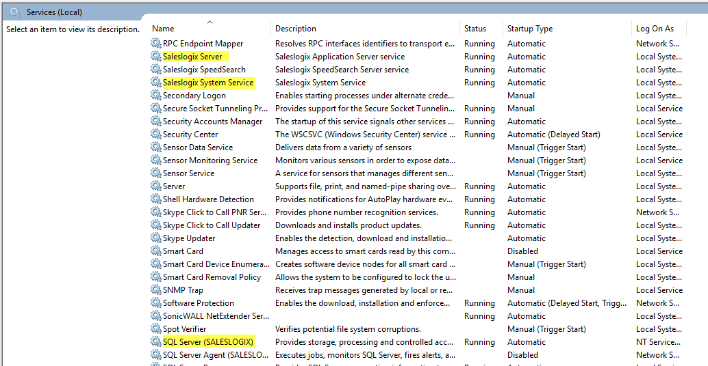Select Administrative Tools
      3. Click on Services
   2. Scroll down to where the Saleslogix Services are located.
   3. Make sure that your Saleslogix Server Service and your SQL Server Service are running.
   4. If they are not…
      1. Right-click on the services that are not running
      2. Select “Start”
2. **Check your “Connections”**
   1. If you have “Connection Manager” installed, open it.
      1. If you don’t have a connection listed, then you may have found your issue!
      2. If you do see a connection:
         1. Select “Edit…”
         2. Before clicking on “Test Connection,” go to the “All Tab”
            1. Scroll down to “Persist Security Info” and make sure that the value is set to “True.” If it is not:

Click on that line

Select “Edit Value…”

In the pop-up window, Select “Reset Value…”

In the drop-down box, select “True”

Close the pop-up window

* + - * 1. Scroll up to “Integrated Security”

Click on that line

Select “Edit Value…”

In the pop-up window, Select “Reset Value…”

Close the pop-up window

* + - 1. Go back to the “Connection” tab
         1. If all of the information is present, click on “Test Connection”
         2. If your connection is successful, you’re good to go!
         3. If your connection failed:

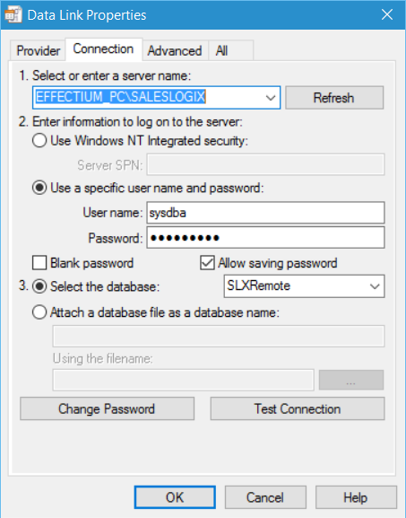Make sure you have the correct SQL Server name in the first section. The Server name should appear in the drop-down box. However, if it doesn’t you can manually enter it.

Make sure the radio button next to “Use a specific user name and password” is selected

Deselect “Blank password”

Select “Allow saving password”

Enter the User Name and Password for the “sysdba” user.

Make sure the radio button next to “Select the database:” is selected.

Select your database from the drop-down box.

If your database is not in the dropdown box:

Make sure your services are running

Make sure the database is installed

Go back up to step 2 and verify the “All” tab settings.

* + - * 1. Test your connection again.
        2. If your connection failed: Call me!!
        3. If it passed, click on “OK,”
        4. Click on “OK” again
        5. Click on “Apply”
        6. One last time: Click on “OK”
  1. Now go to your Infor CRM Application (it doesn’t matter which one) and click on the ellipses (…)
     1. Once again, if you don’t have a ___, you may have found your problem! Otherwise:
     2. Make sure that your SalesLogix Server is appearing in the dropbox.
        1. If it isn’t:
           1. Check your services
           2. Check your Connection Manager
     3. Then make sure your SalesLogix database name is also showing up in the dropbox.
        1. If it isn’t:
           1. Check your services
           2. Check your Connection Manager
     4. Type in your Saleslogix (Infor CRM) User Name and Password
     5. Select “Test Connection”
     6. If it fails:
        1. Check your services!
     7. If it succeeds: You should be good to go!!

These instructions aren’t all inclusive, nor will they fix all of your potential connection issues. If none of those steps worked, feel free to contact me at [canderson@effectium.com](mailto:canderson@effectium.com) and I’ll try to help you through it. If it did work, we’re glad we could help!!